**West Coast Collaborative**

**Investigation 1 2016**

**Circles in the Complex Plane**

**Take Home Section – due Thursday 18 February**

**Validation of your findings will take place on that day, with 100% weighting on the validation.**

**Calculator but no notes will be allowed in the validation.**

**Name: ____Solutions___________________________**

*Answer all questions on separate paper and provide full working to justify your answers.*

Consider the points and  in the complex plane as shown in the diagram below.



The locus of all points in the plane which are equidistant from points  and , form a straight line. Draw this line on the diagram.

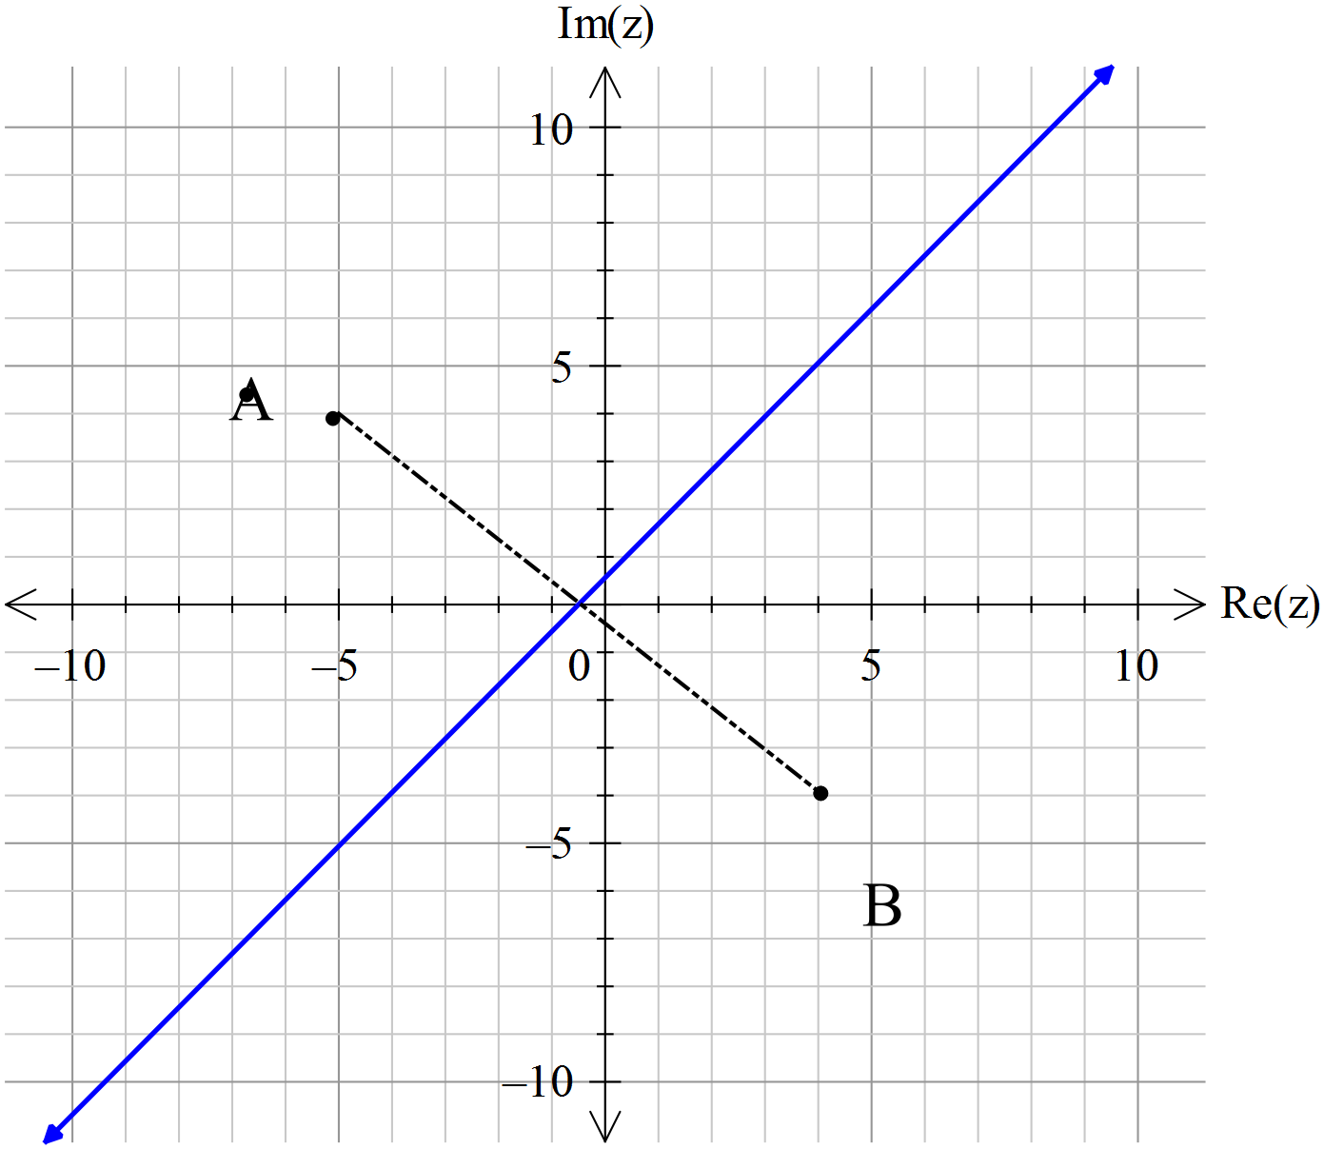

If the point  is given by the vector  and the point  is the given by the vector then the line you have just drawn consists of those points in the plane which satisfy the complex equation

 where ........….(1)

However, if , then the required points in the plane are twice as far from point A as they are from point B.

**Question 1.**

Given that  is the point (-5, 4) and B is the point (4, -4), draw the locus of equation (1) as shown above, when .

An A4 sheet of graph paper is provided for this purpose.



**Question 2**

Using a ruler and compass, repeat the above for ,

using 10 well spaced points.

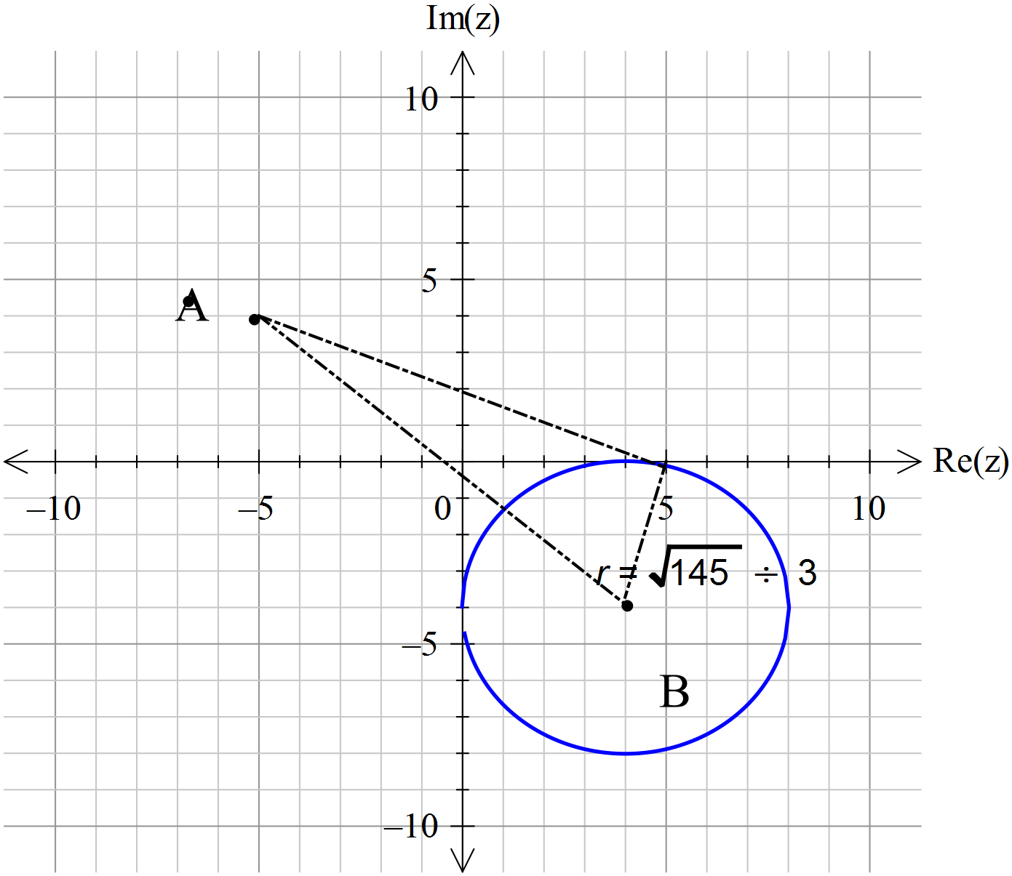

**Question 3**.

By investigating the locus of the points defined by the general equation (1) above, find the apparent shape of the locus when n = 3 or 4. 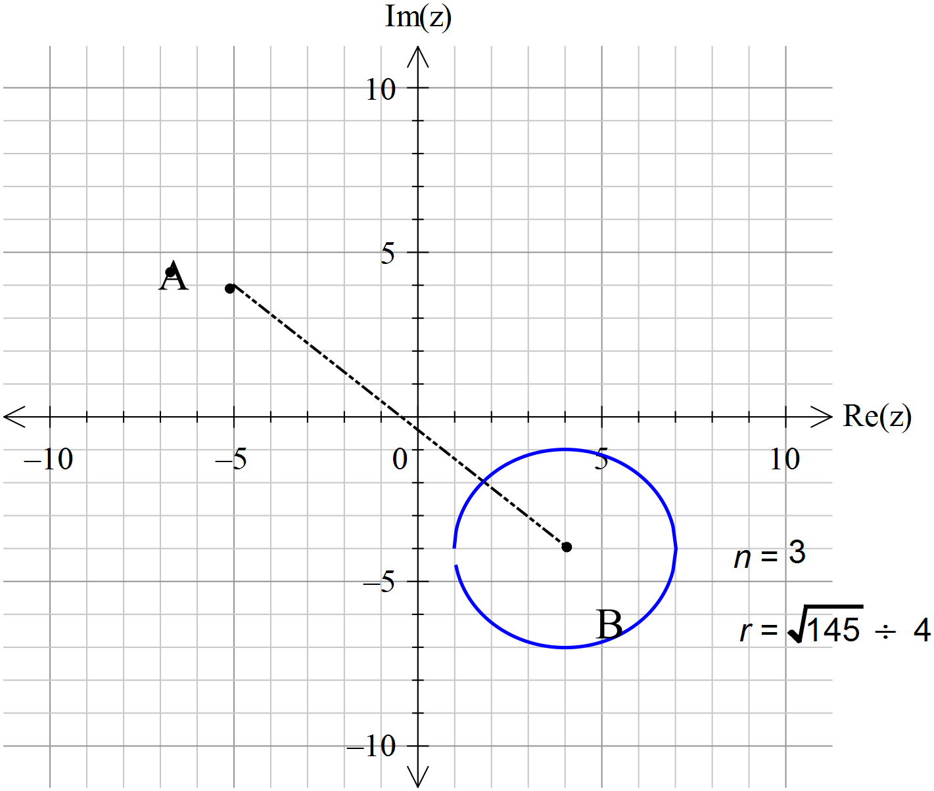

###### **Question 4**

For the special case of  at (0,0) and  being any point on the real axis, show that the locus of the points which satisfy the equation  must be a circle for all positive values of , 

Hints :

1. Let be *x + iy* and then use the fact that 
2. A circle has general form (x – h)2 + (y – k)2 = r2
3. Use the process of completing the square

Let 

















This shows that the locus is a circle because it takes the form



**Question 5**

In the above proof you have specifically located  at the origin, and point ****on the  axis, to simplify a problem which could otherwise become impossibly complicated. This strategy of finding a solution to a simplified problem which can then be applied to more complex situations is a standard approach to problem solving in mathematics.

Use the mathematical concept of *transformations* to argue why this situation can be generalised for points and  anywhere in the plane.

In other words, argue the proposition that

For any value ,  the locus of the points that satisfy the equation

 is a circle.

*The transformation from the origin to any point A is a translation that does not alter the shape of the locus, only the point of origin.*

**Question 6**

a) Use vector techniques to show that for this general equation, the radius of the circle is . *Show all working.*

The diagram that follows should give you a starting point .

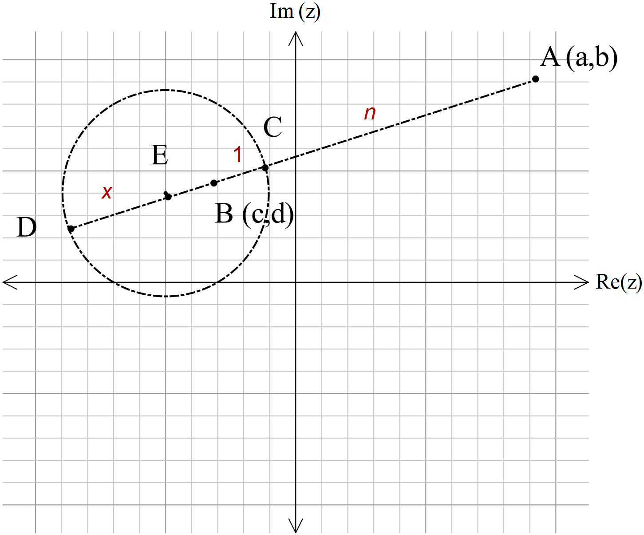

*In the diagram shown E is the centre of the circle where C and D lie on the circumference.*

*The point C is n times further from A than from B.*

*Likewise D*  *is n times further from A than from B.*

If we make 

Then 









*So* 









*Radius* , 

**

**

**

**

b) Given that the centre of the circle is the mid point of CD in the above diagram, show also that the centre of the circle is the point

( , )

*By the same token*

**

*=*

**

**

**

**

**

**

 is (c-a) on real axis and (d-b) on imaginary

*So E is* ( , )

Since E lies on a projection of the line AB.

**Question 7**

Use the function graphing facility of your graphic calculator to examine the behaviour of the radius , as a function of  for any values of A and B. ie the function 

Present your findings graphically and discuss the behaviour of the function for .

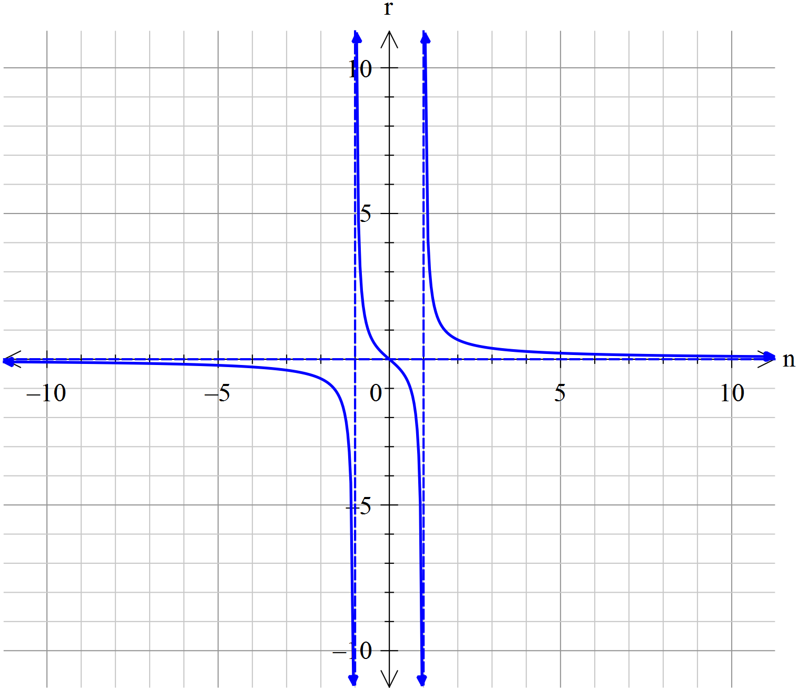

## 

## Question 8

Now use the above considerations and the concept of a limit to explain why, in the case of , the locus of the points which satisfy the equation

 is a straight line.

*As the radius tends to infinity all of the “curve” is lost, and the locus becomes a straight line.*

**Question 9**

What happens to the locus as****increases without bound ie, n ∞ ?

*As n tends to infinity the radius tends to 0, making the circle a single point.*

### END OF EXTENDED PIECE OF WORK